Rhombus-Base Pyramid
# Source: AI Source: Provided by: [Data Path: Persons Table -> ID Column: 1, Name_En Column: Motasem Essam] -> From: [ChatGPT] on [7/25/2026]
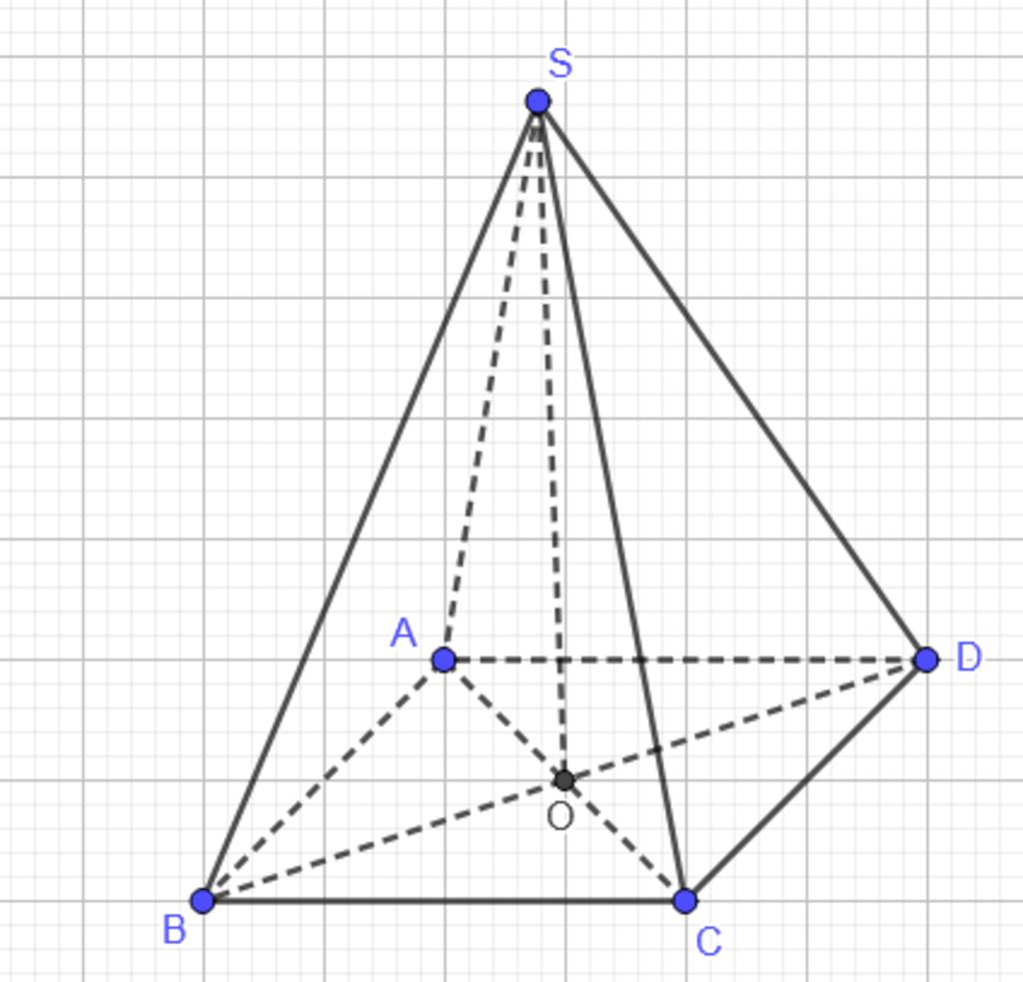
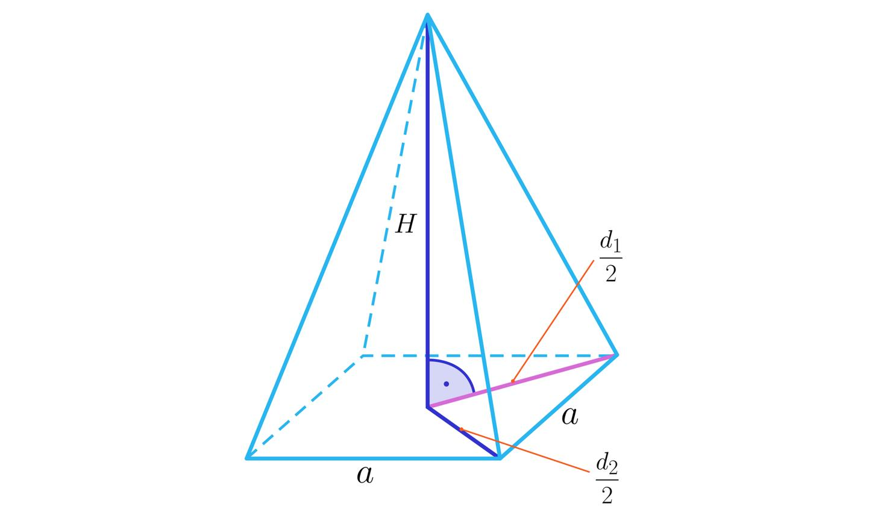
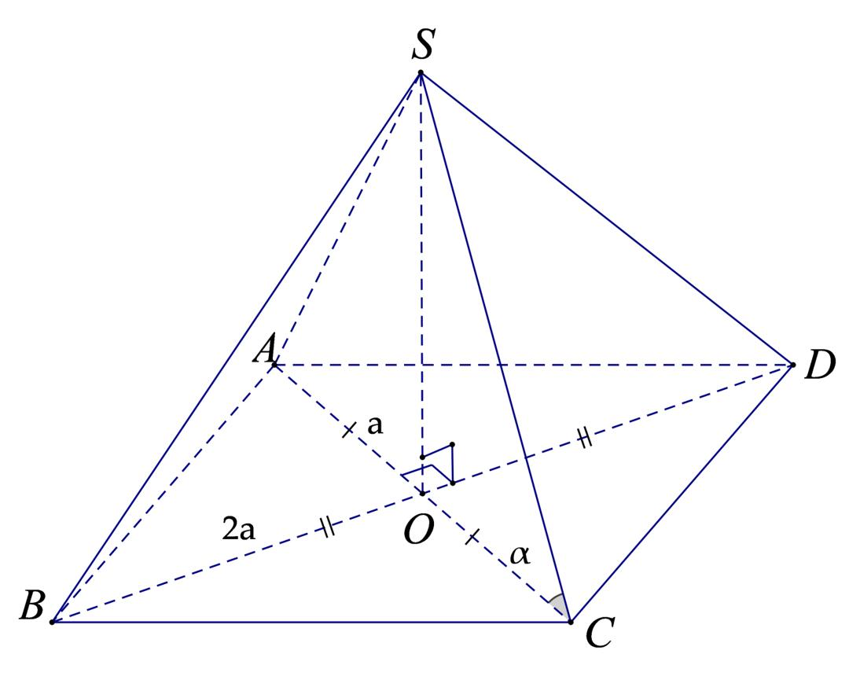

Definition
# Source: AI Source: Provided by: [Data Path: Persons Table -> ID Column: 1, Name_En Column: Motasem Essam] -> From: [ChatGPT] on [7/25/2026]
A rhombus-base pyramid is a three-dimensional polyhedron with a rhombus as its base and four triangular lateral faces that meet at a single vertex called the apex.
A rhombus is a quadrilateral with four equal sides. Its opposite sides are parallel, and its opposite angles are equal. However, its angles are not necessarily ${90}^{∘}$.
The pyramid has five faces, eight edges, and five vertices. Its lateral faces connect the apex to the four vertices of the rhombus base.
A rhombus-base pyramid may be right or oblique, depending on the position of the apex relative to the designated center of the base.
Important: A square is a special type of rhombus. Therefore, a square-base pyramid is also a rhombus-base pyramid under the inclusive mathematical definition of a rhombus.

Simple Definition
# Source: AI Source: Provided by: [Data Path: Persons Table -> ID Column: 1, Name_En Column: Motasem Essam] -> From: [ChatGPT] on [7/25/2026]
A rhombus-base pyramid is a solid with one diamond-shaped rhombus base and four triangular sides that meet at one apex.

Key Characteristics
# Source: AI Source: Provided by: [Data Path: Persons Table -> ID Column: 1, Name_En Column: Motasem Essam] -> From: [ChatGPT] on [7/25/2026]
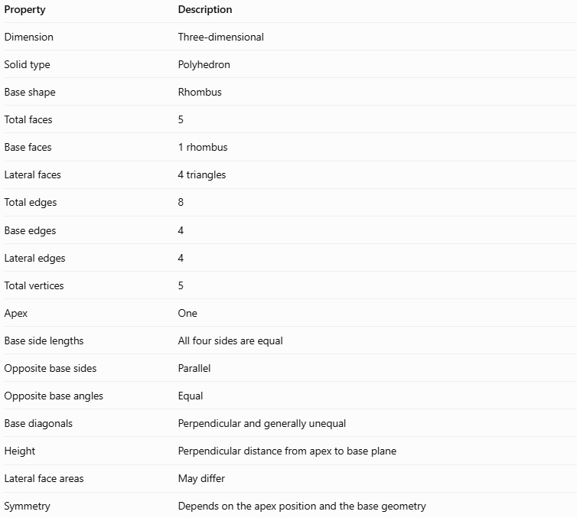
Property | Description
Dimension | Three-dimensional
Solid type | Polyhedron
Base shape | Rhombus
Total faces | 5
Base faces | 1 rhombus
Lateral faces | 4 triangles
Total edges | 8
Base edges | 4
Lateral edges | 4
Total vertices | 5
Apex | One
Base side lengths | All four sides are equal
Opposite base sides | Parallel
Opposite base angles | Equal
Base diagonals | Perpendicular and generally unequal
Height | Perpendicular distance from apex to base plane
Lateral face areas | May differ
Symmetry | Depends on the apex position and the base geometry

Geometric Representation
# Source: AI Source: Provided by: [Data Path: Persons Table -> ID Column: 1, Name_En Column: Motasem Essam] -> From: [ChatGPT] on [7/25/2026]
The main components of a rhombus-base pyramid are:
- Rhombus base $ABCD$: The quadrilateral forming the base, with four equal sides.
- Apex $S$: The vertex where all four lateral faces meet.
- Base edges $AB$, $BC$, $CD$, and $DA$: The four equal-length sides of the rhombus.
- Lateral edges $SA$, $SB$, $SC$, and $SD$: The edges connecting the apex to the base vertices.
- Lateral faces $SAB$, $SBC$, $SCD$, and $SDA$: The four triangular side faces.
- Base diagonals $AC$ and $BD$: The diagonals of the rhombus. They bisect each other at right angles.
- Base center $O$: The intersection of the two diagonals.
- Perpendicular height $h$: The perpendicular distance from the apex to the base plane.
- Slant heights: The altitudes of the lateral triangular faces, measured perpendicular to their respective base edges.
For a right rhombus-base pyramid, the apex lies directly above the base center $O$:
$$SO⊥\text{plane}\left(ABCD\right)$$
For an oblique rhombus-base pyramid, the perpendicular projection of the apex onto the base plane does not coincide with the designated center.

Mathematical Representations and Formulas
# Source: AI Source: Provided by: [Data Path: Persons Table -> ID Column: 1, Name_En Column: Motasem Essam] -> From: [ChatGPT] on [7/25/2026]
Let:
- $a$ = side length of the rhombus base.
- $d_{1},d_{2}$ = lengths of the two diagonals.
- $θ$ = one interior angle of the rhombus.
- $h$ = perpendicular height of the pyramid.
- $B$ = base area.
- $A_{L}$ = lateral surface area.
- $A_{T}$ = total surface area.
- $V$ = volume.

Base area
# Source: AI Source: Provided by: [Data Path: Persons Table -> ID Column: 1, Name_En Column: Motasem Essam] -> From: [ChatGPT] on [7/25/2026]
The area of a rhombus can be calculated using its diagonals:
$$\boxed{B=\frac{1}{2}d_{1}d_{2}}$$
Alternatively, if the side length and an interior angle are known:
$$\boxed{B=a^{2}\sin{θ}}$$
These formulas calculate the area of the rhombus base, not the surface area of the entire pyramid.

Base perimeter
# Source: AI Source: Provided by: [Data Path: Persons Table -> ID Column: 1, Name_En Column: Motasem Essam] -> From: [ChatGPT] on [7/25/2026]
Since all four sides of the rhombus are equal:
$$\boxed{P_{b}=4a}$$

Number of faces, edges, and vertices
# Source: AI Source: Provided by: [Data Path: Persons Table -> ID Column: 1, Name_En Column: Motasem Essam] -> From: [ChatGPT] on [7/25/2026]
For a pyramid with an $n$-sided base:
$$F=n+1, E=2n, V_{e}=n+1$$
For a rhombus-base pyramid, $n=4$:
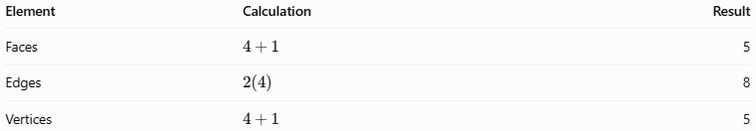
Element | Calculation | Result
Faces | $$4+1$$ | 5
Edges | $$2\left(4\right)$$ | 8
Vertices | $$4+1$$ | 5
Euler's formula for convex polyhedra is:
$$V_{e}-E+F=2$$
Substituting:
$$5-8+5=2$$
Therefore, the rhombus-base pyramid satisfies Euler's formula.

Volume
# Source: AI Source: Provided by: [Data Path: Persons Table -> ID Column: 1, Name_En Column: Motasem Essam] -> From: [ChatGPT] on [7/25/2026]
The volume of any pyramid is:
$$V=\frac{1}{3}Bh$$
Using the diagonal formula for the rhombus base:
$$\boxed{V=\frac{1}{6}d_{1}d_{2}h}$$
Alternatively:
$$\boxed{V=\frac{1}{3}a^{2}h\sin{θ}}$$
These formulas apply to both right and oblique rhombus-base pyramids.

Lateral surface area
# Source: AI Source: Provided by: [Data Path: Persons Table -> ID Column: 1, Name_En Column: Motasem Essam] -> From: [ChatGPT] on [7/25/2026]
For a general rhombus-base pyramid, calculate each triangular face separately:
$$\boxed{A_{L}=A_{1}+A_{2}+A_{3}+A_{4}}$$
For a right rhombus-base pyramid, the apex is above the intersection of the diagonals. Opposite vertices are equally distant from this center, so opposite lateral faces are congruent in pairs.
However, the two pairs of lateral faces generally have different areas because the rhombus's diagonals are generally unequal.
If $l_{1}$ and $l_{2}$ are the slant heights corresponding to the two pairs of opposite base edges, then:
$$A_{L}=2\left(\frac{1}{2}al_{1}\right)+2\left(\frac{1}{2}al_{2}\right)$$
Simplifying:
$$\boxed{A_{L}=a\left(l_{1}+l_{2}\right)}$$
This formula assumes a right pyramid with the apex above the center of the rhombus.

Total surface area
# Source: AI Source: Provided by: [Data Path: Persons Table -> ID Column: 1, Name_En Column: Motasem Essam] -> From: [ChatGPT] on [7/25/2026]
For a right rhombus-base pyramid:
$$A_{T}=B+A_{L}$$
Therefore:
$$\boxed{A_{T}=\frac{1}{2}d_{1}d_{2}+a\left(l_{1}+l_{2}\right)}$$
For an oblique rhombus-base pyramid, use the general formula:
$$\boxed{A_{T}=\frac{1}{2}d_{1}d_{2}+A_{1}+A_{2}+A_{3}+A_{4}}$$
The lateral faces should be calculated individually unless their geometry establishes equal areas or a common slant height.

Relationship between diagonals and side length
# Source: AI Source: Provided by: [Data Path: Persons Table -> ID Column: 1, Name_En Column: Motasem Essam] -> From: [ChatGPT] on [7/25/2026]
The diagonals of a rhombus bisect each other at right angles. Each side is therefore the hypotenuse of a right triangle with legs $d_{1}/2$ and $d_{2}/2$.
By the Pythagorean theorem:
$$a^{2}={\left(\frac{d_{1}}{2}\right)}^{2}+{\left(\frac{d_{2}}{2}\right)}^{2}$$
Thus:
$$\boxed{a=\frac{1}{2}\sqrt{d_{1}^{2}+d_{2}^{2}}}$$
This relationship is useful when the diagonals are known but the side length is not.

Worked Examples
# Source: AI Source: Provided by: [Data Path: Persons Table -> ID Column: 1, Name_En Column: Motasem Essam] -> From: [ChatGPT] on [7/25/2026]
Example 1: Calculating the base area
A rhombus-base pyramid has a rhombus base with diagonals of $10\text{ cm}$ and $8\text{ cm}$.
Using:
$$B=\frac{1}{2}d_{1}d_{2}$$
Substitute:
$$B=\frac{1}{2}\left(10\right)\left(8\right)$$
$$\boxed{B=40{\text{ cm}}^{2}}$$
Answer: The base area is $40{\text{ cm}}^{2}$.
Example 2: Calculating volume
A rhombus-base pyramid has base diagonals of $12\text{ cm}$ and $10\text{ cm}$, and a perpendicular height of $9\text{ cm}$.
Step 1: Calculate the base area.
$$B=\frac{1}{2}\left(12\right)\left(10\right)=60{\text{ cm}}^{2}$$
Step 2: Calculate the volume.
$$V=\frac{1}{3}Bh$$
$$V=\frac{1}{3}\left(60\right)\left(9\right)$$
$$\boxed{V=180{\text{ cm}}^{3}}$$
Answer: The volume is $180{\text{ cm}}^{3}$.
Example 3: Calculating the base side length
A rhombus base has diagonals of $6\text{ cm}$ and $8\text{ cm}$.
Using:
$$a=\frac{1}{2}\sqrt{d_{1}^{2}+d_{2}^{2}}$$
Substitute:
$$a=\frac{1}{2}\sqrt{6^{2}+8^{2}}$$
$$a=\frac{1}{2}\sqrt{36+64}$$
$$a=\frac{1}{2}\sqrt{100}$$
$$\boxed{a=5\text{ cm}}$$
Answer: Each side of the rhombus measures $5\text{ cm}$.

Comparison with Related Concepts
# Source: AI Source: Provided by: [Data Path: Persons Table -> ID Column: 1, Name_En Column: Motasem Essam] -> From: [ChatGPT] on [7/25/2026]
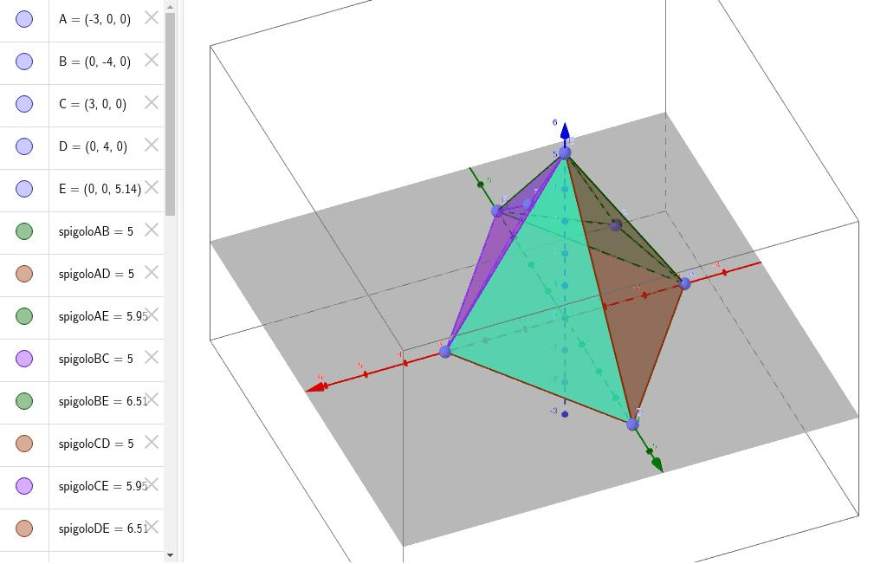
Rhombus-Base Pyramid
Has a rhombus base with four equal sides. The base angles do not have to be right angles.
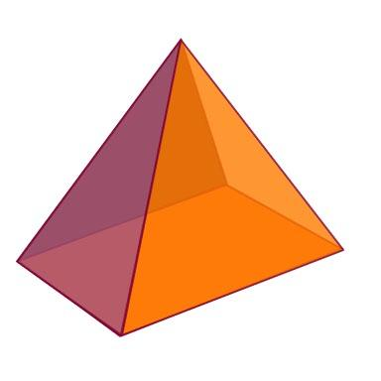
Square-Base Pyramid
Has a square base with four equal sides and four right angles. It is a special case of a rhombus-base pyramid.
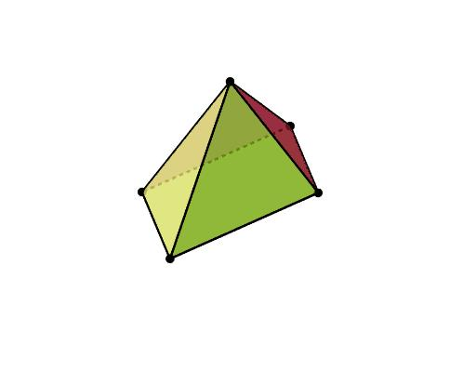
Parallelogram-Base Pyramid
Has a parallelogram base with opposite sides equal and parallel. Adjacent sides need not be equal.
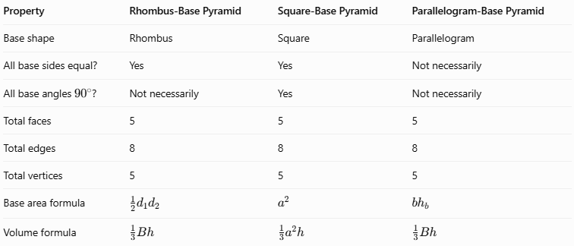
Property | Rhombus-Base Pyramid | Square-Base Pyramid | Parallelogram-Base Pyramid
Base shape | Rhombus | Square | Parallelogram
All base sides equal? | Yes | Yes | Not necessarily
All base angles \(90^\circ\)? | Not necessarily | Yes | Not necessarily
Total faces | 5 | 5 | 5
Total edges | 8 | 8 | 8
Total vertices | 5 | 5 | 5
Base area formula | $$\frac{1}{2}d_{1}d_{2}$$ | $$a^{2}$$ | $$bh_{b}$$
Volume formula | $$\frac{1}{3}Bh$$ | $$\frac{1}{3}a^{2}h$$ | $$\frac{1}{3}Bh$$

Constructing Rhombus-Base Pyramid in Solid Geometry

Instruments Used
# Source: AI Source: Provided by: [Data Path: Persons Table -> ID Column: 1, Name_En Column: Motasem Essam] -> From: [ChatGPT] on [7/25/2026]
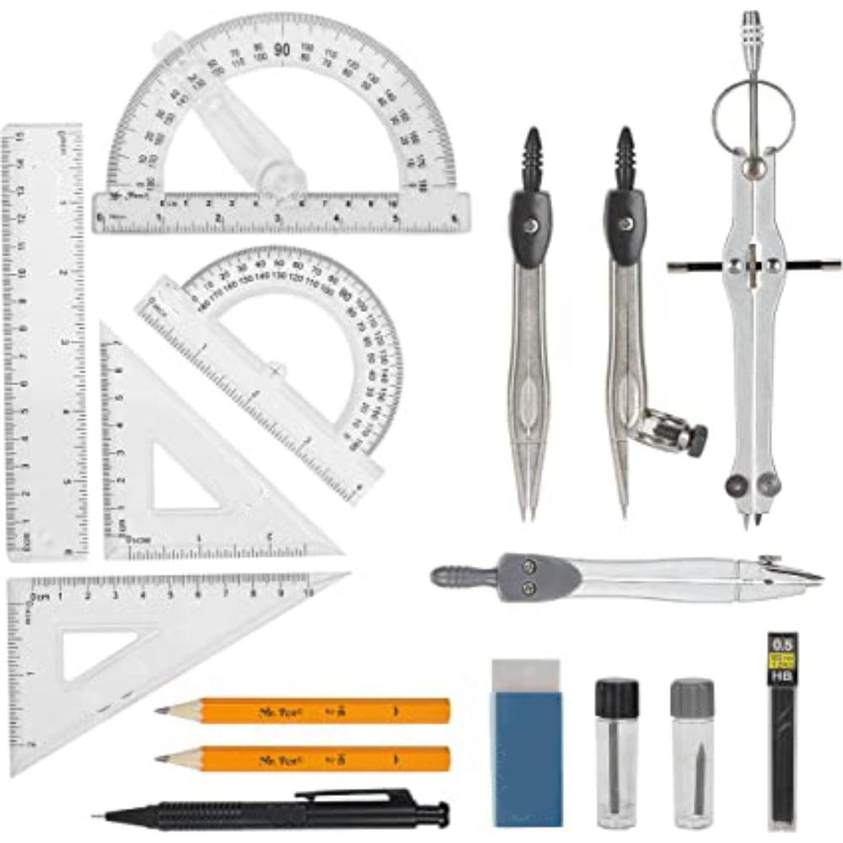
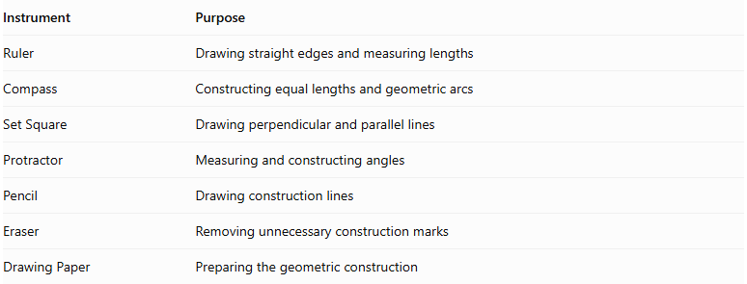
Instrument | Purpose
Ruler | Drawing straight edges and measuring lengths
Compass | Constructing equal lengths and geometric arcs
Set Square | Drawing perpendicular and parallel lines
Protractor | Measuring and constructing angles
Pencil | Drawing construction lines
Eraser | Removing unnecessary construction marks
Drawing Paper | Preparing the geometric construction
Construction Method: Instrument-Based

Construction Procedures

Constructing the Rhombus Base
# Source: AI Source: Provided by: [Data Path: Persons Table -> ID Column: 1, Name_En Column: Motasem Essam] -> From: [ChatGPT] on [7/25/2026]
- Draw one diagonal of the rhombus using a ruler.
- Mark its midpoint.
- Construct a perpendicular line through the midpoint using a compass and ruler.
- Mark the midpoint of the second diagonal on the perpendicular line.
- Mark equal distances on both sides of the midpoint to establish the endpoints of the second diagonal.
- Connect the four diagonal endpoints to form the rhombus.
- Verify that all four sides are equal.

Constructing a Right Rhombus-Base Pyramid
# Source: AI Source: Provided by: [Data Path: Persons Table -> ID Column: 1, Name_En Column: Motasem Essam] -> From: [ChatGPT] on [7/25/2026]
- Construct the rhombus base.
- Draw its two diagonals to locate their intersection, which is the center of the base.
- Draw a perpendicular line through the center.
- Mark the desired perpendicular height on this line.
- Label the endpoint as the apex.
- Connect the apex to all four base vertices.
- Draw visible edges using solid lines.
- Draw hidden edges using dashed lines where appropriate.

Constructing an Oblique Rhombus-Base Pyramid
# Source: AI Source: Provided by: [Data Path: Persons Table -> ID Column: 1, Name_En Column: Motasem Essam] -> From: [ChatGPT] on [7/25/2026]
- Construct the rhombus base.
- Select an apex position that is not directly above the center of the rhombus.
- Draw the apex above the base plane.
- Connect the apex to all four base vertices.
- Distinguish visible and hidden edges.
- Verify that all four lateral faces are triangular.
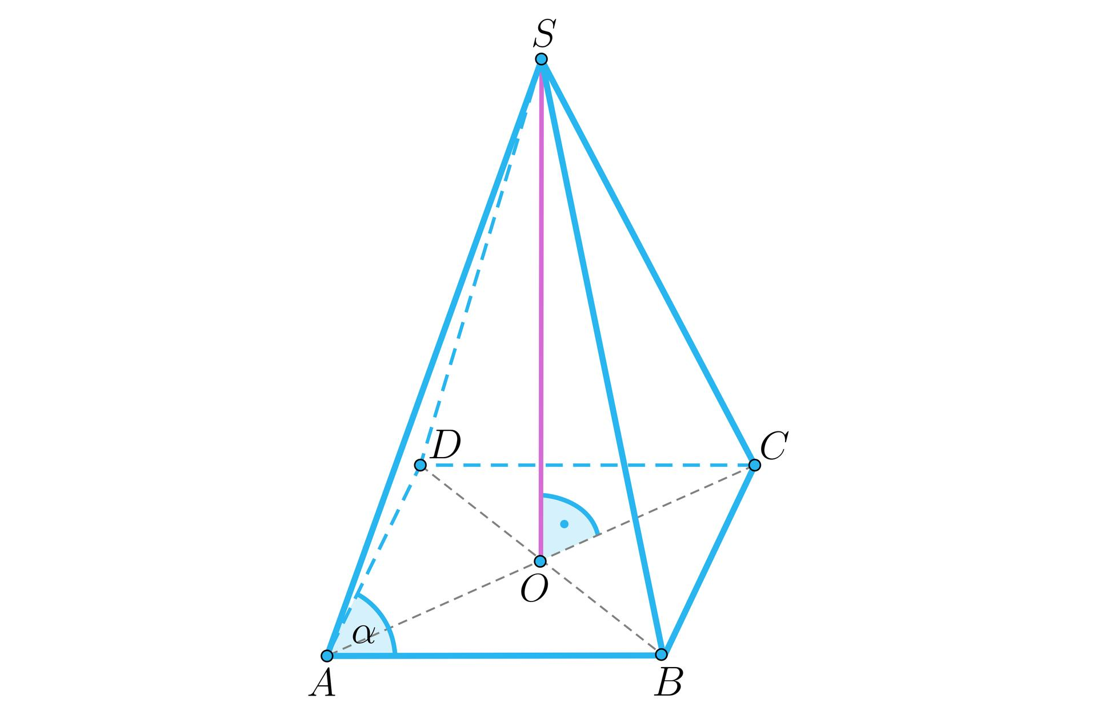

Constructing the Net of a Rhombus-Base Pyramid
# Source: AI Source: Provided by: [Data Path: Persons Table -> ID Column: 1, Name_En Column: Motasem Essam] -> From: [ChatGPT] on [7/25/2026]
- Draw a rhombus representing the base.
- Construct four triangular faces, one attached to each side of the rhombus.
- Determine the dimensions of each triangle from the corresponding lateral edges.
- Add joining flaps if the net is intended for physical assembly.
- Cut and fold the net to form the pyramid.
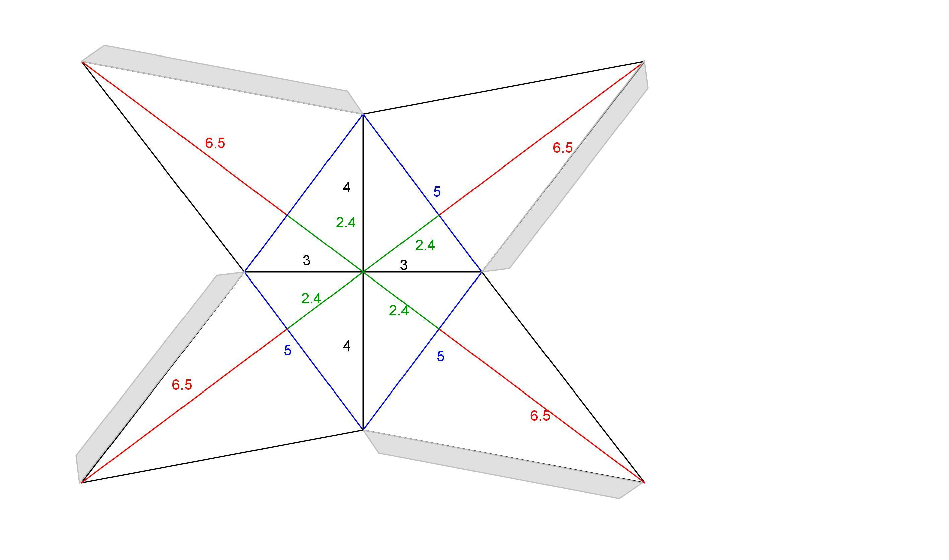

Applications
# Source: AI Source: Provided by: [Data Path: Persons Table -> ID Column: 1, Name_En Column: Motasem Essam] -> From: [ChatGPT] on [7/25/2026]
- Architecture: Modeling tapered structures with diamond-shaped footprints.
- Engineering: Representing components with rhombic bases and triangular side faces.
- Computer graphics: Constructing three-dimensional polygonal models.
- Mathematics education: Studying quadrilateral properties, diagonals, surface area, and volume.
- Geometric modeling: Exploring how changing the base angles affects the shape and area of a pyramid without changing the number of its faces, edges, or vertices.

Key Points
# Source: AI Source: Provided by: [Data Path: Persons Table -> ID Column: 1, Name_En Column: Motasem Essam] -> From: [ChatGPT] on [7/25/2026]
- A rhombus-base pyramid has one rhombus base and four triangular lateral faces.
- It has 5 faces, 8 edges, and 5 vertices.
- All four sides of its base are equal.
- Its base diagonals intersect at right angles and bisect each other.
- The base area is \(\frac12d_1d_2\).
- Its volume is \(\frac13Bh\), or \(\frac16d_1d_2h\).
- Its lateral surface area is the sum of its four triangular face areas.
- A square-base pyramid is a special case of a rhombus-base pyramid.
- The perpendicular height is distinct from the slant heights and lateral edges.

Conclusion
# Source: AI Source: Provided by: [Data Path: Persons Table -> ID Column: 1, Name_En Column: Motasem Essam] -> From: [ChatGPT] on [7/25/2026]
A rhombus-base pyramid is a polyhedron with a rhombus base and four triangular lateral faces that meet at a single apex. It has five faces, eight edges, and five vertices. Its base is characterized by four equal sides and diagonals that bisect each other at right angles.
Its volume is calculated using one-third of the base area multiplied by the perpendicular height. Its surface area is obtained by adding the areas of the rhombus base and the four triangular lateral faces. Understanding this pyramid helps connect the properties of quadrilaterals with the geometry of three-dimensional solids.

